1 DispSync

1.1 DispSync概述
这里面有涉及到一个重要的类DispSync，是android在4.4之后添加的。
DispSync维护了一个这样的模型（VSync事件模型）：利用显示设备的硬件VSync事件周期性的特征，在硬件Vsync事件特定的偏移处周期性地执行回调函数。即只要显示设备的Vsync硬件事件周期性地到来，DispSync就会在Vsync事件到来的特定时间偏移点，执行相应的回调函数。具体实现是通过addResyncSample方法向DispSync对象喂连续的硬件事件时间戳。
有了这个DispSync模型之后，每次从底层收到一个硬件产生的VSync事件，都会进行判断，是否有必要继续产生硬件VSync事件，只有当它认为与硬件VSync事件有偏离时（即时间戳与硬件对应的Fence对象上的时间戳偏移超出预设的值时），才需要启用硬件产生VSync事件，否则，它就可以代表底层的VSync事件，无需硬件产生VSync事件，从而达到省电的目的。另外一种情况就是主动请求开启HWComposer Vsync。
模型过程如下：
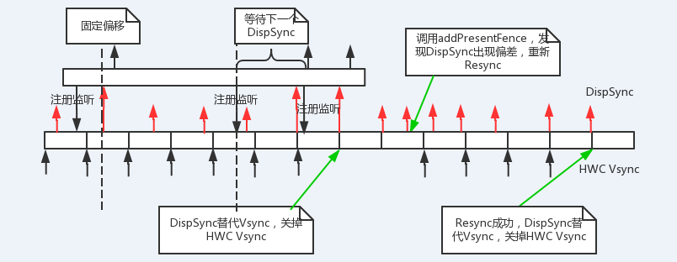
DispSync类的构造函数：
DispSync::DispSync() :
mRefreshSkipCount(0),
mThread(new DispSyncThread()) {

mThread->run("DispSync", PRIORITY_URGENT_DISPLAY + PRIORITY_MORE_FAVORABLE);

reset();
beginResync();

if (kTraceDetailedInfo) {
// If we're not getting present fences then the ZeroPhaseTracer
// would prevent HW vsync event from ever being turned off.
// Even if we're just ignoring the fences, the zero-phase tracing is
// not needed because any time there is an event registered we will
// turn on the HW vsync events.
if (!kIgnorePresentFences) {
addEventListener(0, new ZeroPhaseTracer());
}
}

构造函数主要完成两个事情：
- 初始化成员变量；
- 创建一个thread。
接下来我们来看下DispSync类的构造函数：
class DispSync {

public:

class Callback: public virtual RefBase {
public:
virtual ~Callback() {};
virtual void onDispSyncEvent(nsecs_t when) = 0;
};

DispSync();
~DispSync();

// reset clears the resync samples and error value.
void reset();

// addPresentFence adds a fence for use in validating the current vsync
// event model. The fence need not be signaled at the time
// addPresentFence is called. When the fence does signal, its timestamp
// should correspond to a hardware vsync event. Unlike the
// addResyncSample method, the timestamps of consecutive fences need not
// correspond to consecutive hardware vsync events.
//
// This method should be called with the retire fence from each HWComposer
// set call that affects the display.
// 函数主要用于验证当前的VSync模型是否正常，即有没有偏离实际的硬件VSync时间戳。当返回值为true时，表明当前Vsync Event模型已经与硬件Vsync事件偏离，需要重新同步。
bool addPresentFence(const sp<Fence>& fence);

// The beginResync, addResyncSample, and endResync methods are used to re-
// synchronize the DispSync's model to the hardware vsync events. The re-
// synchronization process involves first calling beginResync, then
// calling addResyncSample with a sequence of consecutive hardware vsync
// event timestamps, and finally calling endResync when addResyncSample
// indicates that no more samples are needed by returning false.
//
// This resynchronization process should be performed whenever the display
// is turned on (i.e. once immediately after it's turned on) and whenever
// addPresentFence returns true indicating that the model has drifted away
// from the hardware vsync events.
// 当Vsync事件模型时间戳与硬件对应的Fence对象的时间戳偏离后，需要依次调用上述三个接口来同步，只要addResyncSample()返回false，就表明已经同步完成，此时VSync 事件模型与硬件Vsync事件又保持一致了。
void beginResync();
bool addResyncSample(nsecs_t timestamp);
void endResync();

// The setPeriod method sets the vsync event model's period to a specific
// value. This should be used to prime the model when a display is first
// turned on. It should NOT be used after that.
void setPeriod(nsecs_t period);

// The getPeriod method returns the current vsync period.
nsecs_t getPeriod();

// setRefreshSkipCount specifies an additional number of refresh
// cycles to skip. For example, on a 60Hz display, a skip count of 1
// will result in events happening at 30Hz. Default is zero. The idea
// is to sacrifice smoothness for battery life.
void setRefreshSkipCount(int count);

// addEventListener registers a callback to be called repeatedly at the
// given phase offset from the hardware vsync events. The callback is
// called from a separate thread and it should return reasonably quickly
// (i.e. within a few hundred microseconds).
status_t addEventListener(nsecs_t phase, const sp<Callback>& callback);

// removeEventListener removes an already-registered event callback. Once
// this method returns that callback will no longer be called by the
// DispSync object.
status_t removeEventListener(const sp<Callback>& callback);

// computeNextRefresh computes when the next refresh is expected to begin.
// The periodOffset value can be used to move forward or backward; an
// offset of zero is the next refresh, -1 is the previous refresh, 1 is
// the refresh after next. etc.
nsecs_t computeNextRefresh(int periodOffset) const;

// dump appends human-readable debug info to the result string.
void dump(String8& result) const;

private:

void updateModelLocked();
void updateErrorLocked();
void resetErrorLocked();

enum { MAX_RESYNC_SAMPLES = 32 };
enum { MIN_RESYNC_SAMPLES_FOR_UPDATE = 3 };
enum { NUM_PRESENT_SAMPLES = 8 };
enum { MAX_RESYNC_SAMPLES_WITHOUT_PRESENT = 12 };

// mPeriod is the computed period of the modeled vsync events in
// nanoseconds.
nsecs_t mPeriod;

// mPhase is the phase offset of the modeled vsync events. It is the
// number of nanoseconds from time 0 to the first vsync event.
// 该变量用来表示DispSync和Vsync之间的offset
nsecs_t mPhase;

// mError is the computed model error. It is based on the difference
// between the estimated vsync event times and those observed in the
// mPresentTimes array.
nsecs_t mError;

// These member variables are the state used during the resynchronization
// process to store information about the hardware vsync event times used
// to compute the model.
// mResyncSamples用来存储每一次vsync到来时候的时间戳
// mFirstResyncSample用来标识第一次记录时候在mResyncSamples数组中的index
// mNumResyncSamples本次模型同步过程经历的vysnc次数
nsecs_t mResyncSamples[MAX_RESYNC_SAMPLES];
size_t mFirstResyncSample;
size_t mNumResyncSamples;
int mNumResyncSamplesSincePresent;

// These member variables store information about the present fences used
// to validate the currently computed model.
sp<Fence> mPresentFences[NUM_PRESENT_SAMPLES];
nsecs_t mPresentTimes[NUM_PRESENT_SAMPLES];
size_t mPresentSampleOffset;

int mRefreshSkipCount;

// mThread is the thread from which all the callbacks are called.
sp<DispSyncThread> mThread;

// mMutex is used to protect access to all member variables.
mutable Mutex mMutex;
};

}

1.2 DispSync模型
DispSync模型本质上是一个Loop循环，在这个循环中：
- 时间间隔由参数mPeriod & mPhase来决定；
- 通过调用Condition::waitRelative来实现时间间隔的控制；
- 达到时间间隔后，就收集注册的监听。如果存在，就回调监听函数。
virtual bool threadLoop() {
status_t err;
nsecs_t now = systemTime(SYSTEM_TIME_MONOTONIC);
nsecs_t nextEventTime = 0;

while (true) {
Vector<CallbackInvocation> callbackInvocations;

nsecs_t targetTime = 0;

{ // Scope for lock
Mutex::Autolock lock(mMutex);

if (mStop) {
return false;
}

if (mPeriod == 0) {
err = mCond.wait(mMutex);
if (err != NO_ERROR) {
ALOGE("error waiting for new events: %s (%d)",
strerror(-err), err);
return false;
}
continue;
}
// 时间间隔由参数mPeriod & mPhase来决定，计算下一次Event时间间隔
nextEventTime = computeNextEventTimeLocked(now);
targetTime = nextEventTime;

bool isWakeup = false;

// 通过调用Condition::waitRelative来实现时间间隔的控制；
if (now < targetTime) {
err = mCond.waitRelative(mMutex, targetTime - now);

if (err == TIMED_OUT) {
isWakeup = true;
} else if (err != NO_ERROR) {
ALOGE("error waiting for next event: %s (%d)",
strerror(-err), err);
return false;
}
}

now = systemTime(SYSTEM_TIME_MONOTONIC);

if (isWakeup) {
mWakeupLatency = ((mWakeupLatency * 63) +
(now - targetTime)) / 64;
if (mWakeupLatency > 500000) {
// Don't correct by more than 500 us
mWakeupLatency = 500000;
}
if (kTraceDetailedInfo) {
ATRACE_INT64("DispSync:WakeupLat", now - nextEventTime);
ATRACE_INT64("DispSync:AvgWakeupLat", mWakeupLatency);
}
}
// 达到时间间隔后，就收集注册的监听。如果存在，就回调监听函数。

callbackInvocations = gatherCallbackInvocationsLocked(now);
}

if (callbackInvocations.size() > 0) {
fireCallbackInvocations(callbackInvocations);
}
}

return false;
}
接下来，我们来看下如何计算时间间隔。
nsecs_t computeNextEventTimeLocked(nsecs_t now) {
nsecs_t nextEventTime = INT64_MAX;
// 分别计算每一个listener对应的NextEventTime。怎么理解呢？简单点就是这个listener将在接下来的哪一个DispSync中被触发。
for (size_t i = 0; i < mEventListeners.size(); i++) {
nsecs_t t = computeListenerNextEventTimeLocked(mEventListeners[i],
now);

if (t < nextEventTime) {
nextEventTime = t;
}
}

return nextEventTime;
}

nsecs_t computeListenerNextEventTimeLocked(const EventListener& listener,
nsecs_t ref) {

nsecs_t lastEventTime = listener.mLastEventTime;
if (ref < lastEventTime) {
ref = lastEventTime;
}
// 最近一次的DispSync的时间节点
nsecs_t phase = mPhase + listener.mPhase;
nsecs_t t = (((ref - phase) / mPeriod) + 1) * mPeriod + phase;
// 如果距离下一次的DispSync的时间节点小于mPeriod的一半的话，这个listener就等到下下个DispSync来处理。
if (t - listener.mLastEventTime < mPeriod / 2) {
t += mPeriod;
}

return t;
}

1.3 DispSync模型的建立
DispSync的模型是通过HWC Vsync逐步建立起来的。其基于的参数有mPeriod&mPhase。这小节，我们就来看这两个参数是如何构建的。
我们之前有分析过，每一次HWC Vsync（Soft Vsync/Hw Vsync)到来的时候，就会触发onVSyncReceived（）的调用。在onVSyncReceived中会调用addResyncSample（）开启模型的建立。
bool DispSync::addResyncSample(nsecs_t timestamp) {
Mutex::Autolock lock(mMutex);

size_t idx = (mFirstResyncSample + mNumResyncSamples) % MAX_RESYNC_SAMPLES;
mResyncSamples[idx] = timestamp;

if (mNumResyncSamples < MAX_RESYNC_SAMPLES) {
mNumResyncSamples++;
} else {
mFirstResyncSample = (mFirstResyncSample + 1) % MAX_RESYNC_SAMPLES;
}

updateModelLocked();

if (mNumResyncSamplesSincePresent++ > MAX_RESYNC_SAMPLES_WITHOUT_PRESENT) {
resetErrorLocked();
}

if (kIgnorePresentFences) {
// If we don't have the sync framework we will never have
// addPresentFence called. This means we have no way to know whether
// or not we're synchronized with the HW vsyncs, so we just request
// that the HW vsync events be turned on whenever we need to generate
// SW vsync events.
return mThread->hasAnyEventListeners();
}

return mPeriod == 0 || mError > kErrorThreshold;
}
在分析具体实现之前，先看看几个参数：
- mResyncSamples是一个循环数组，用来记录每一次vsync过来的时间戳。
- mFirstResyncSample 用来标记本次同步的第一个vsync时间戳在mResyncSamples中的存储位置。
- mNumResyncSamples：用来标记本次同步需要的vsync个数
addResyncSample（）首先将参数中的timestamp保存到mResyncSamples，然后调用updateModelLocked()进行模型的更新。
void DispSync::updateModelLocked() {
// 对于存储在mResyncSamples数组的时间戳进行处理，算出vsync的时间间隔。算法比较简单，就是取每一个vysnc到来的时间间隔，然后取平均值。
if (mNumResyncSamples >= MIN_RESYNC_SAMPLES_FOR_UPDATE) {
nsecs_t durationSum = 0;
for (size_t i = 1; i < mNumResyncSamples; i++) {
size_t idx = (mFirstResyncSample + i) % MAX_RESYNC_SAMPLES;
size_t prev = (idx + MAX_RESYNC_SAMPLES - 1) % MAX_RESYNC_SAMPLES;
durationSum += mResyncSamples[idx] - mResyncSamples[prev];
}

mPeriod = durationSum / (mNumResyncSamples - 1);

// mPhase用来表示DispSync和Vsync之间的相位差，可以理解成构建的DispSync比Vsync晚多长时间开始生成。
double sampleAvgX = 0;
double sampleAvgY = 0;
double scale = 2.0 * M_PI / double(mPeriod);
for (size_t i = 0; i < mNumResyncSamples; i++) {
size_t idx = (mFirstResyncSample + i) % MAX_RESYNC_SAMPLES;
nsecs_t sample = mResyncSamples[idx];
double samplePhase = double(sample % mPeriod) * scale;
sampleAvgX += cos(samplePhase);
sampleAvgY += sin(samplePhase);
}

sampleAvgX /= double(mNumResyncSamples);
sampleAvgY /= double(mNumResyncSamples);

mPhase = nsecs_t(atan2(sampleAvgY, sampleAvgX) / scale);

if (mPhase < 0) {
mPhase += mPeriod;
}

if (kTraceDetailedInfo) {
ATRACE_INT64("DispSync:Period", mPeriod);
ATRACE_INT64("DispSync:Phase", mPhase);
}

// Artificially inflate the period if requested.
mPeriod += mPeriod * mRefreshSkipCount;

// 然后又根据新的mPeriod和mPhase来更新模型
mThread->updateModel(mPeriod, mPhase);
}
}
可是，什么时候模型才算是真正建立完成呢？
从addResyncSample的返回值可以知道，return mPeriod == 0 || mError > kErrorThreshold;，只要mPeriod=0，或是mError>160000000000就表示模型还需要继续更新。
mError是一个全局变量，用来表示DispSync 的mPeriod和HWC Vsync Period之间的方差。在DispSync的模型中，mError的更新是通过updateErrorLocked() 来进行的。
void DispSync::updateErrorLocked() {
if (mPeriod == 0) {
return;
}

// Need to compare present fences against the un-adjusted refresh period,
// since they might arrive between two events.
nsecs_t period = mPeriod / (1 + mRefreshSkipCount);

int numErrSamples = 0;
nsecs_t sqErrSum = 0;

// 求（DispSync的mPeriod和Vsync的Period）方差
for (size_t i = 0; i < NUM_PRESENT_SAMPLES; i++) {
nsecs_t sample = mPresentTimes[i];
if (sample > mPhase) {
nsecs_t sampleErr = (sample - mPhase) % period;
if (sampleErr > period / 2) {
sampleErr -= period;
}
sqErrSum += sampleErr * sampleErr;
numErrSamples++;
}
}

// 方差平均值
if (numErrSamples > 0) {
mError = sqErrSum / numErrSamples;
} else {
mError = 0;
}

if (kTraceDetailedInfo) {
ATRACE_INT64("DispSync:Error", mError);
}
}
从上面的分析可以知道，当模型建立完成之后，mPrimaryDispSync.addResyncSample就会返回false，然后就调用disableHardwareVsync将HWC Vsync停掉。
整个模型建立的流程图如下：
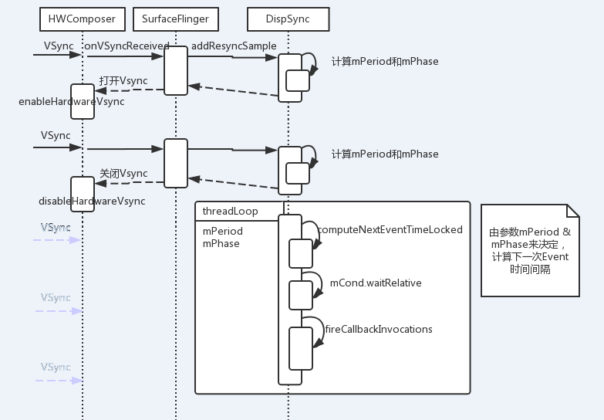

1.4 重新对齐HWC Vsync
在7.2.3中我们讨论到了，当DispSync的间隔和HWC Vsync的间隔的方差小于一定的范围的时候，就表示对齐成功，然后关掉HWC Vsync。并且，在关掉HWC Vsync之后，还会时刻校验DispSync的情况，以便随时打开HWC Vsync重新对齐。
在7.2.3中，我们有提到，在DispSync的模型中，mError的更新是通过updateErrorLocked() 来进行的。那么updateErrorLocked（）是在哪儿被调用的呢？
答案是：DispSync::addPresentFence（）。这里不详细展开说明，只是给出调用流程，有兴趣的同学可以直接去看代码。
SurfaceFlinger::handleMessageRefresh() ==> SurfaceFlinger::postComposition() ==> DispSync::addPresentFence()。
SurfaceFlinger::postComposition()主要完成3个事情：
- 回调onPostComposition()，通知layer，合成已经完成；
- 重新审查DispSync模型
- 出现anim
我们这里重点看看2）部分。
void SurfaceFlinger::postComposition()
{
。。。。。。
const HWComposer& hwc = getHwComposer();
sp<Fence> presentFence = hwc.getDisplayFence(HWC_DISPLAY_PRIMARY);

if (presentFence->isValid()) {
if (mPrimaryDispSync.addPresentFence(presentFence)) {
enableHardwareVsync();
} else {
disableHardwareVsync(false);
}
}

if (kIgnorePresentFences) {
const sp<const DisplayDevice> hw(getDefaultDisplayDevice());
if (hw->isDisplayOn()) {
enableHardwareVsync();
}
}
。。。。。。
}
从上面关键代码可以看出，首先是通过hwcomposer来获取一个fence，然后调用DispSync::addPresentFence（）来审查DispSync的情况。

1.4.1 Fence的获取
首先来看看Fence的获取。
sp<Fence> HWComposer::getDisplayFence(int disp) const {
return mDisplayData[disp].lastDisplayFence;
}
status_t HWComposer::commit() {
int err = NO_ERROR;
if (mHwc) {
if (!hwcHasApiVersion(mHwc, HWC_DEVICE_API_VERSION_1_1)) {
// On version 1.0, the OpenGL ES target surface is communicated
// by the (dpy, sur) fields and we are guaranteed to have only
// a single display.
mLists[0]->dpy = eglGetCurrentDisplay();
mLists[0]->sur = eglGetCurrentSurface(EGL_DRAW);
}

for (size_t i=VIRTUAL_DISPLAY_ID_BASE; i<mNumDisplays; i++) {
DisplayData& disp(mDisplayData[i]);
if (disp.outbufHandle) {
mLists[i]->outbuf = disp.outbufHandle;
mLists[i]->outbufAcquireFenceFd =
disp.outbufAcquireFence->dup();
}
}

err = mHwc->set(mHwc, mNumDisplays, mLists);

for (size_t i=0 ; i<mNumDisplays ; i++) {
DisplayData& disp(mDisplayData[i]);
disp.lastDisplayFence = disp.lastRetireFence;
disp.lastRetireFence = Fence::NO_FENCE;
if (disp.list) {
if (disp.list->retireFenceFd != -1) {
disp.lastRetireFence = new Fence(disp.list->retireFenceFd);
disp.list->retireFenceFd = -1;
}
disp.list->flags &= ~HWC_GEOMETRY_CHANGED;
}
}
}
return (status_t)err;
}
可以看到，在commit()函数中，有disp.lastDisplayFence = disp.lastRetireFence; disp.lastRetireFence = new Fence(disp.list->retireFenceFd);这样，问题就转到去追寻disp.list->retireFenceFd的赋值。
这里也不继续展开了，只是简单介绍了commit（）函数调用的流程。
SurfaceFlinger::handleMessageRefresh() ==> SurfaceFlinger::doComposition() ==> SurfaceFlinger::postFramebuffer() ==> HWComposer::commit()。
接下来给出disp.list->retireFenceFd的赋值函数的调用流程。
SurfaceFlinger::handleMessageRefresh() ==> SurfaceFlinger::doComposition() ==> SurfaceFlinger::postFramebuffer() ==> HWComposer::commit() ==> hwc->hwc_set() ==> hwc->hwc_set_primary() ==> hwc_utils->hwc_sync().
int hwc_sync(hwc_context_t *ctx, hwc_display_contents_1_t* list, int dpy,
int fd) {
。。。。。。
struct mdp_buf_sync data;
memset(&data, 0, sizeof(data));
data.acq_fen_fd = acquireFd;
data.rel_fen_fd = &releaseFd;
data.retire_fen_fd = &retireFd;
。。。。。。
//Waits for acquire fences, returns a release fence
if(LIKELY(!swapzero)) {
uint64_t start = systemTime();
ret = ioctl(fbFd, MSMFB_BUFFER_SYNC, &data);
ALOGD_IF(HWC_UTILS_DEBUG, "%s: time taken for MSMFB_BUFFER_SYNC IOCTL = %d",
__FUNCTION__, (size_t) ns2ms(systemTime() - start));
}

。。。。。。
if(UNLIKELY(swapzero))
list->retireFenceFd = -1;
else
list->retireFenceFd = retireFd;
return ret;
}

Hwc_sync首先创建一个data结构体，然后通过ioctl MSMFB_BUFFER_SYNC从fb设备中获取数据填充到data结构体中。最后返回releaseFd并完成list->retireFenceFd的赋值。具体ioctl的实现可以参考：https://android.googlesource.com/kernel/msm/+/android-6.0.1_r0.18/ drivers/video/msm/mdss/mdss_fb.c

1.4.2 DispSync模型校正
首先来分析addPresentFence（）的实现：
bool DispSync::addPresentFence(const sp<Fence>& fence) {
Mutex::Autolock lock(mMutex);
//首先将fence添加到mPresentFences
mPresentFences[mPresentSampleOffset] = fence;
mPresentTimes[mPresentSampleOffset] = 0;
mPresentSampleOffset = (mPresentSampleOffset + 1) % NUM_PRESENT_SAMPLES;
mNumResyncSamplesSincePresent = 0;

// 遍历mPresentFences数组，获取每一个fence的signal时间戳+kPresentTimeOffset（0）后，赋值给mPresentTimes数组。
for (size_t i = 0; i < NUM_PRESENT_SAMPLES; i++) {
const sp<Fence>& f(mPresentFences[i]);
if (f != NULL) {
nsecs_t t = f->getSignalTime();
if (t < INT64_MAX) {
mPresentFences[i].clear();
mPresentTimes[i] = t + kPresentTimeOffset;
}
}
}

//调用updateErrorLocked来审查DispSync模型。
updateErrorLocked();

return mPeriod == 0 || mError > kErrorThreshold;
}
当方差大于160000000000，则表示DispSync需要重新校正，这个时候就开启HWC Vsync。

1.4.3 小结
当Hwc Vsync产生的时候，会通过HWC模块的传递，最后回调SurfaceFlinger的onVSyncReceived（）。onVSyncReceived（）会触发DispSync进行模型重新计算。更新的模型通过两个参数mPeriod和mPhase来体现。mPeriod用来表示HWC Vsync的时间间隔，mPhase表示DispSync相对于HWC Vsync的相位差。
另一方面，DispSync的ThreadLoop函数实现了DispSync模型，即根据mPeriod和mPhase持续间隔触发fireCallbackInvocations函数调用。时间间隔是通过pthread_cond_timedwait或是pthread_cond_timedwait_relative_np来实现的。fireCallbackInvocations（）函数本质上就是回调注册监听的回调函数callbacks[i].mCallback->onDispSyncEvent(callbacks[i].mEventTime），这样就达到了每一个监听都收到了DispSync的功能。上面提到的监听就是基于DispSync建立的DispSyncSource，比如vsyncSrc&sfVsyncSrc。
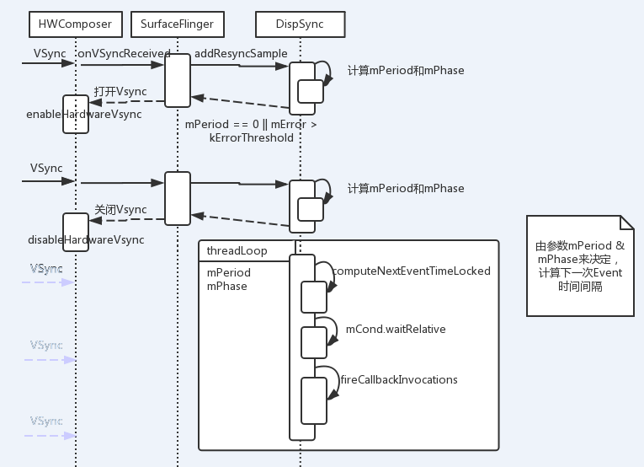
onDispSyncEvent（）会调用onVSyncEvent（），将Event添加到EventThread中。接着就是复杂的Event处理流转过程。最后会调用到SurfaceFlinger：：handleMessageRefresh（）==> postComposition()。
这个过程可以参考第8章，对应的时序图为：
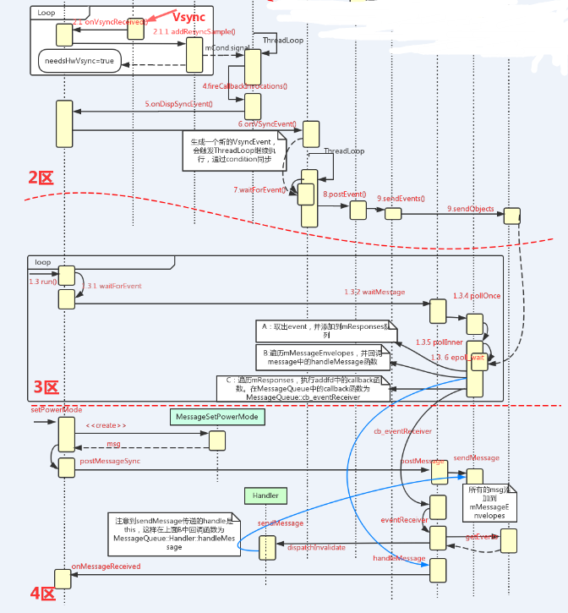
我们在回来看看模型判断过程。
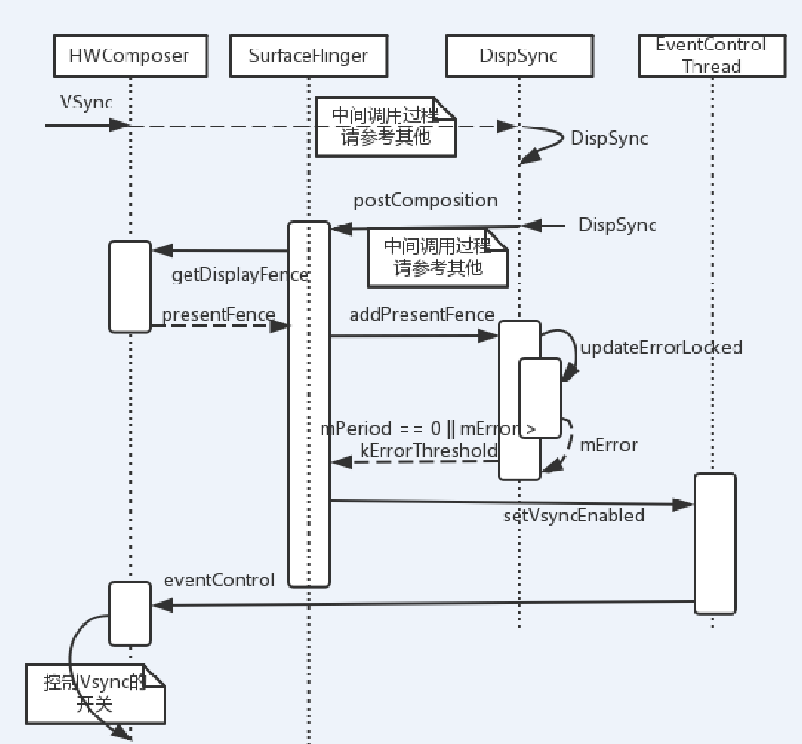

1.5 Dump DispSync信息
shell@hwmt7:/ $ dumpsys SurfaceFlinger --dispsync
dumpsys SurfaceFlinger --dispsync
present fences are used
mPeriod: 16543645 ns (60.446 fps; skipCount=0)
mPhase: 2312283 ns
mError: 1606467030 ns (sqrt=40080.8)
mNumResyncSamplesSincePresent: 0 (limit 12)
mNumResyncSamples: 3 (max 32)
mResyncSamples:
199899174714
199915718672 (+16543958)
199932262005 (+16543333)
mPresentFences / mPresentTimes [8]:
200296201797 (889.153 ms ago)
200312739714 (+16537917 / 1.000) (872.615 ms ago)
200329273880 (+16534166 / 0.999) (856.081 ms ago)
200345818255 (+16544375 / 1.000) (839.537 ms ago)
200362358880 (+16540625 / 1.000) (822.996 ms ago)
200378885130 (+16526250 / 0.999) (806.470 ms ago)
200395428255 (+16543125 / 1.000) (789.927 ms ago)
[unsignaled fence]
current monotonic time: 201185355130
一些关键的数据整理如下：
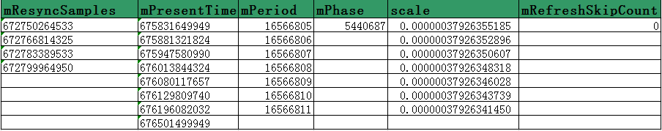

2 VSyncSource
VSyncSource代表了一个Vsync事件源，EventThread类目前直接通过VSyncSource获取VSync事件信息。所以，理论上，只有维护好VSync源，EventThread就会源源不断地收到VSync事件，而至于VSync源是否依赖于底层硬件真实的VSync事件信号，则对EventThread来说，是完全透明的。这样就实现了EventThread和Vsync产生的解耦。
VSyncSource的定义如下：
class VSyncSource : public virtual RefBase {
public:
class Callback: public virtual RefBase {
public:
virtual ~Callback() {}
virtual void onVSyncEvent(nsecs_t when) = 0;
};

virtual ~VSyncSource() {}
virtual void setVSyncEnabled(bool enable) = 0;
virtual void setCallback(const sp<Callback>& callback) = 0;
};
可以看到VSyncSource是一个纯虚类，在surfaceflinger中定义了一个内部类DispSyncSource实现了VsyncSource的方法，该类实际上是通过DispSync类定义的事件模型来维护一个VSync事件源。
DispSyncSource的调用示例：
// start the EventThread
sp<VSyncSource> vsyncSrc = new DispSyncSource(&mPrimaryDispSync,
vsyncPhaseOffsetNs, true, "app");
DispSyncSource的实现：
class DispSyncSource : public VSyncSource, private DispSync::Callback {
public:
DispSyncSource(DispSync* dispSync, nsecs_t phaseOffset, bool traceVsync,
const char* label) :
mValue(0),
mPhaseOffset(phaseOffset),
mTraceVsync(traceVsync),
mVsyncOnLabel(String8::format("VsyncOn-%s", label)),
mVsyncEventLabel(String8::format("VSYNC-%s", label)),
mDispSync(dispSync) {}

virtual ~DispSyncSource() {}

virtual void setVSyncEnabled(bool enable) {
// Do NOT lock the mutex here so as to avoid any mutex ordering issues
// with locking it in the onDispSyncEvent callback.
if (enable) {
status_t err = mDispSync->addEventListener(mPhaseOffset,
static_cast<DispSync::Callback*>(this));
if (err != NO_ERROR) {
ALOGE("error registering vsync callback: %s (%d)",
strerror(-err), err);
}
//ATRACE_INT(mVsyncOnLabel.string(), 1);
} else {
status_t err = mDispSync->removeEventListener(
static_cast<DispSync::Callback*>(this));
if (err != NO_ERROR) {
ALOGE("error unregistering vsync callback: %s (%d)",
strerror(-err), err);
}
//ATRACE_INT(mVsyncOnLabel.string(), 0);
}
}

// 在enableVSyncLocked（）@EventThread.cpp中，会调用setCallback（）完成mCallback的赋值。从mVSyncSource->setCallback(static_cast<VSyncSource::Callback*>(this));可以看到，这个callback就是EventThread的一个对象。
virtual void setCallback(const sp<VSyncSource::Callback>& callback) {
Mutex::Autolock lock(mMutex);
mCallback = callback;
}

// DispSync类会通过DispSyncThread类调用DispSyncSource的onDispSyncEvent，在该方法中会调用EventThread的onVSyncEvent函数。
private:
virtual void onDispSyncEvent(nsecs_t when) {
sp<VSyncSource::Callback> callback;
{
Mutex::Autolock lock(mMutex);
callback = mCallback;

if (mTraceVsync) {
mValue = (mValue + 1) % 2;
ATRACE_INT(mVsyncEventLabel.string(), mValue);
}
}

if (callback != NULL) {
callback->onVSyncEvent(when);
}
}

int mValue;

const nsecs_t mPhaseOffset;
const bool mTraceVsync;
const String8 mVsyncOnLabel;
const String8 mVsyncEventLabel;

DispSync* mDispSync;
sp<VSyncSource::Callback> mCallback;
Mutex mMutex;
};

void EventThread::onVSyncEvent(nsecs_t timestamp) {
Mutex::Autolock _l(mLock);
mVSyncEvent[0].header.type = DisplayEventReceiver::DISPLAY_EVENT_VSYNC;
mVSyncEvent[0].header.id = 0;
mVSyncEvent[0].header.timestamp = timestamp;
mVSyncEvent[0].vsync.count++;
mCondition.broadcast();
}
在函数onVsyncEvevnt中，会根据上传上来的timestamp来创建一个VSyncEvent。这样完成了timestamp到Event的转化。同时mCondition.broadcast发出了命令，那么EventThread中waitforEvent的等待就会被唤醒。EventThread的ThreadLoop就会继续执行，完成对应Event的处理。关于Event的处理，请参考第8章《Surfaceflinger中的Event的处理》。
在SurfaceFlinger的init（）函数中，创建两个VSyncSource对象。
// start the EventThread
sp<VSyncSource> vsyncSrc = new DispSyncSource(&mPrimaryDispSync,
vsyncPhaseOffsetNs, true, "app");
mEventThread = new EventThread(vsyncSrc);
sp<VSyncSource> sfVsyncSrc = new DispSyncSource(&mPrimaryDispSync,
sfVsyncPhaseOffsetNs, true, "sf");
实际上就是创建了两个VSyncSource，对应mPrimaryDispSync的偏移为vsyncPhaseOffsetNs和sfVsyncPhaseOffsetNs。这两个变量定义在SurfaceFlinger中。
static const int64_t vsyncPhaseOffsetNs = VSYNC_EVENT_PHASE_OFFSET_NS;

// This is the phase offset at which SurfaceFlinger's composition runs.
static const int64_t sfVsyncPhaseOffsetNs = SF_VSYNC_EVENT_PHASE_OFFSET_NS;
而从代码来看，是创建了一个app VSync source 和一个SF VSync source？这又是为什么呢？
我们知道，现在的surfaceflinger的工作是流水线的模型。完成一帧内容的绘制需要有三个步骤：1）app绘制，2）SurfaceFlinger合并渲染，3）上屏显示，这部分由framebuffer来完成。如果这三个步骤都由同一个vsync来控制完成的话，那么就意味这需要3个vysnc来完成一帧画面的显示。这样严重影响到了用户的体验。
于是在android kk之后，android引入了DispSync模型，将硬件Vsync虚拟化。将硬件的Vsync信号先同步到本地的Vsync模型中，再从中一分为二，引出两条Vsync时间与之有固定偏移的线程。而这两个偏移就是通过vsyncPhaseOffsetNs和sfVsyncPhaseOffsetNs来指定，这两个Vsync就是App Vsync & SF Vsync。
这个过程的示意图如下：
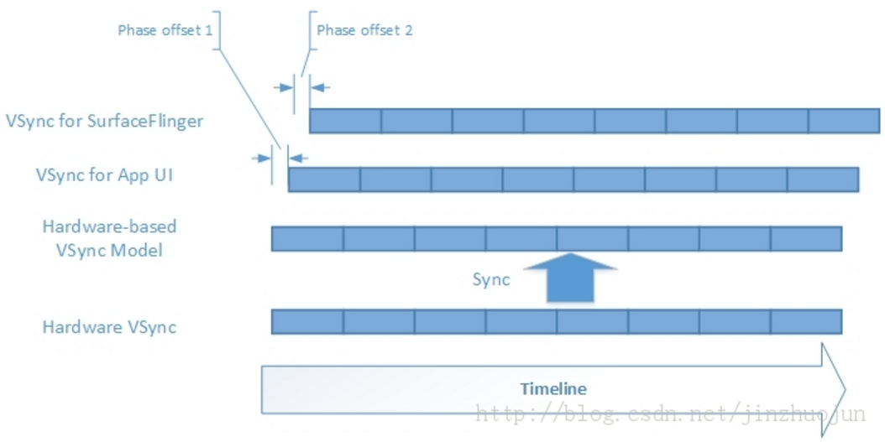
这样app & surfaceflinger就避免了由同一个vsync唤醒而导致的cpu资源抢占的问题，加上一个小小的延迟，让这两个工作并不是同时被唤醒，这样大家就可以错开使用资源的高峰期，提高工作的效率。
那么mPrimaryDispSync又是什么呢？
我们需要回头来看看Vsync在surfaceflinger中的处理函数：onVSyncReceived
void SurfaceFlinger::onVSyncReceived(int type, nsecs_t timestamp) {
bool needsHwVsync = false;

{ // Scope for the lock
Mutex::Autolock _l(mHWVsyncLock);
if (type == 0 && mPrimaryHWVsyncEnabled) {
needsHwVsync = mPrimaryDispSync.addResyncSample(timestamp);
}
}

if (needsHwVsync) {
enableHardwareVsync();
} else {
disableHardwareVsync(false);
}
}
现在明白了，mPrimaryDispSync就是我们一直提到的VSync在surfaceflinger层面的一个封装。在HWComposer中产生的软/硬件Vsync，统一成一个timestamp传递给了Surfaceflinger，然后调用DispSync的addResyncSample完成对接。

3 注册DispSync监听
上文提到了，类似vsyncSrc和sfVsyncSrc需要向DispSync注册，才能监听到DispSync。requestNextVsync()函数本质上是surfaceflinger请求sfVsyncSrc，向sfVsyncThread注册一个监听，即监听sfVsyncSrc。
什么时候这个函数会被调用呢？
- Transaction change
- LayerUpdate
在这两种情况下，会调用 mEventQueue.invalidate()，在invalidate()函数中调用requestNextVsync().
void SurfaceFlinger::signalTransaction() {
mEventQueue.invalidate();
}

void SurfaceFlinger::signalLayerUpdate() {
mEventQueue.invalidate();
}

void MessageQueue::invalidate() {
#if INVALIDATE_ON_VSYNC
mEvents->requestNextVsync();
#else
mHandler->dispatchInvalidate();
#endif
}

分析 mEvents = eventThread->createEventConnection();过程可以知道，最后调用的应该是EventThread::Connection::requestNextVsync()。
void EventThread::Connection::requestNextVsync() {
mEventThread->requestNextVsync(this);
}

void EventThread::requestNextVsync(
const sp<EventThread::Connection>& connection) {
Mutex::Autolock _l(mLock);
if (connection->count < 0) {
connection->count = 0;
mCondition.broadcast();
}
}
调用到了EventThread咯。设置了connection->count=0，同时释放mCondition。
在EventThread:ThreadLoop中调用的waitforEvent()有这样的片段：
// This will return when (1) a vsync event has been received, and (2) there was
// at least one connection interested in receiving it when we started waiting.
Vector< sp<EventThread::Connection> > EventThread::waitForEvent(
DisplayEventReceiver::Event* event)
{
。。。。。。
// find out connections waiting for events
size_t count = mDisplayEventConnections.size();
for (size_t i=0 ; i<count ; i++) {
sp<Connection> connection(mDisplayEventConnections[i].promote());
if (connection != NULL) {
bool added = false;
if (connection->count >= 0) {
// we need vsync events because at least
// one connection is waiting for it
waitForVSync = true;
if (timestamp) {
// we consume the event only if it's time
// (ie: we received a vsync event)
if (connection->count == 0) {
// fired this time around
connection->count = -1;
signalConnections.add(connection);
added = true;
} else if (connection->count == 1 ||
(vsyncCount % connection->count) == 0) {
// continuous event, and time to report it
signalConnections.add(connection);
added = true;
}
}
}

if (eventPending && !timestamp && !added) {
// we don't have a vsync event to process
// (timestamp==0), but we have some pending
// messages.
signalConnections.add(connection);
}
} else {
// we couldn't promote this reference, the connection has
// died, so clean-up!
mDisplayEventConnections.removeAt(i);
--i; --count;
}
}

// Here we figure out if we need to enable or disable vsyncs
if (timestamp && !waitForVSync) {
// we received a VSYNC but we have no clients
// don't report it, and disable VSYNC events
disableVSyncLocked();
} else if (!timestamp && waitForVSync) {
// we have at least one client, so we want vsync enabled
// (TODO: this function is called right after we finish
// notifying clients of a vsync, so this call will be made
// at the vsync rate, e.g. 60fps. If we can accurately
// track the current state we could avoid making this call
// so often.)
enableVSyncLocked();
}
。。。。。。。
｝
判断是否至少有一个连接，如果有的话，就请求Vsync信息。
void EventThread::enableVSyncLocked() {
if (!mUseSoftwareVSync) {
// never enable h/w VSYNC when screen is off
if (!mVsyncEnabled) {
mVsyncEnabled = true;
mVSyncSource->setCallback(static_cast<VSyncSource::Callback*>(this));
mVSyncSource->setVSyncEnabled(true);
}
}
mDebugVsyncEnabled = true;
sendVsyncHintOnLocked();
}

void EventThread::disableVSyncLocked() {
if (mVsyncEnabled) {
mVsyncEnabled = false;
mVSyncSource->setVSyncEnabled(false);
mDebugVsyncEnabled = false;
}
}
回调到类DispVsyncSource中咯。
virtual void setVSyncEnabled(bool enable) {
// Do NOT lock the mutex here so as to avoid any mutex ordering issues
// with locking it in the onDispSyncEvent callback.
if (enable) {
status_t err = mDispSync->addEventListener(mPhaseOffset,
static_cast<DispSync::Callback*>(this));
if (err != NO_ERROR) {
ALOGE("error registering vsync callback: %s (%d)",
strerror(-err), err);
}
//ATRACE_INT(mVsyncOnLabel.string(), 1);
} else {
status_t err = mDispSync->removeEventListener(
static_cast<DispSync::Callback*>(this));
if (err != NO_ERROR) {
ALOGE("error unregistering vsync callback: %s (%d)",
strerror(-err), err);
}
//ATRACE_INT(mVsyncOnLabel.string(), 0);
}
}
通过这个步骤，就将sfVsyncSrc作为Listener添加到DispVsync的监听列表中。这样当DispVsync事件到来时候，sfVsyncSrc的onDispSyncEvent就会被回调。
virtual void onDispSyncEvent(nsecs_t when) {
sp<VSyncSource::Callback> callback;
{
Mutex::Autolock lock(mMutex);
callback = mCallback;

if (mTraceVsync) {
mValue = (mValue + 1) % 2;
ATRACE_INT(mVsyncEventLabel.string(), mValue);
}
}

if (callback != NULL) {
callback->onVSyncEvent(when);
}
}
天呐，又是一个callback！！！！，太乱咯。
看看这个callback是从mCallback赋值过来，DispSyncSource提供了一个接口来修改mCallback。
virtual void setCallback(const sp<VSyncSource::Callback>& callback) {
Mutex::Autolock lock(mMutex);
mCallback = callback;
}
靠，又跳回去EventThread。
void EventThread::onVSyncEvent(nsecs_t timestamp) {
Mutex::Autolock _l(mLock);
mVSyncEvent[0].header.type = DisplayEventReceiver::DISPLAY_EVENT_VSYNC;
mVSyncEvent[0].header.id = 0;
mVSyncEvent[0].header.timestamp = timestamp;
mVSyncEvent[0].vsync.count++;
mCondition.broadcast();
}

4 小结
这样，整个Vsync的流转过程就可以总结如下：
- 初始化HWComposer的时候，判断是否有HWC硬件，如果没有的话，调用软件模拟Vsync生成，并传递timestamp；而如果有HWC硬件，通过读取“/sys/class/graphics/fb%d/vsync_event”获取到timestamp。
- 在HWComper模块中，通过回调SurfaceFlinger的onVSyncReceived()函数，将timestamp传递到SurfaceFlinger模块中。
- 在SurfaceFlinger模块中，初始化一个成员变量mPrimaryDispSync，用来描述Vsync模型，这是DispVsync数据结构类型。然后调用addResyncSample（）来完成HWC模块上传的timestamp和mPrimaryDispSync的关联。这样，HWC的Vsync信息，就成功关联上了SurfaceFlinger的mPrimaryDispSync。在SurfaceFlinger中，所有的操作就依据mPrimaryDispSync为基准。
- 在SurfaceFlinger中，根据mPrimaryDispSync创建了两个DispSyncSource：app Vsync 和SF Vsync。这两个Vsync和mPrimaryDispSync之间存在一定的延迟，分别为：VSYNC_EVENT_PHASE_OFFSET_NS和SF_VSYNC_EVENT_PHASE_OFFSET_NS。
- 基于app Vsync和SF Vsync创建了appVsyncThread 和sfVsyncThread，分别处理app的绘制和surfaceflinger的混合。由于存在偏差，故可以避免由同一个Vsync导致的抢占资源的情况。

